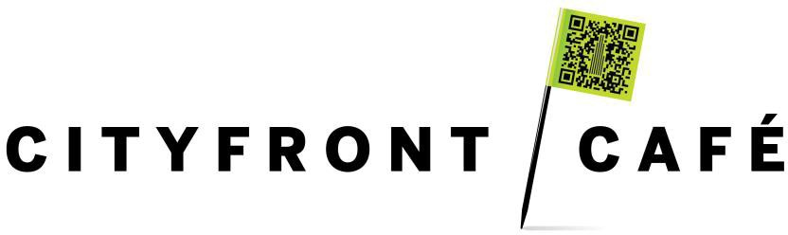

Join us daily for:

Sandwiches
House Made Soups
Hot Entrée
Fresh Salad Bar
Beer
Wine
Hard Seltzer

Hours of Operation: 11:00am– 2:30pm
455 N. Cityfront Plaza Dr. | NBC Tower | Chic a go, IL 60611 www.cityfrontcafe.c om
Telephone: 312-374-1169

